**CS673 Software Engineering** 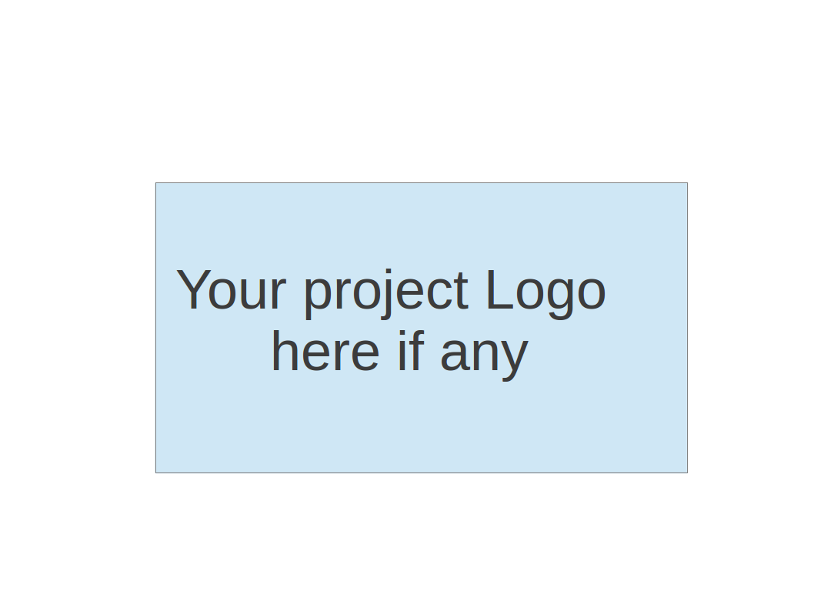

**Team 4 - {Enter Project Name Here}**

**Project Proposal and Planning**

| Team Member | Role(s) | Signature | Date |
| --- | --- | --- | --- |
| Hemant Krishnakumar | Team Lead |  | 09 - 24- 2024 |
| Faizan Ahmad | Design and Implementation Lead |  | 09 - 24- 2024 |
| Tushar | Requirement Lead |  | 09 - 24- 2024 |
| Shubh Gupta | Q/A Lead |  | 09 - 24- 2024 |
| Amruth Reddy | Security Lead |  | 09 - 24- 2024 |
| Jaindra Parvathaneni | Configuration Lead |  | 09 - 24- 2024 |

**Revision history**

| **Version** | **Author** | **Date** | **Change** |
| --- | --- | --- | --- |
| **0** | **Hemant Krishnakumar** | **09-24-2024** |  |
|  |  |  |  |
|  |  |  |  |
|  |  |  |  |

Overview

Related Work

Proposed High level Requirements

Management Plan

Objectives and Priorities

Risk Management (need to be updated constantly)

Timeline (need to be updated at the end of each iteration)

Configuration Management Plan

Tools

Quality Assurance Plan

Metrics

Code Review Process

Testing

Defect Management

References

Glossary

# Overview

An ATS-like resume reviewer with a recruiter and applicant side. Recruiters get full access to all resumes ranked(scores based on JD). They would also have a personal dashboard which would provide advanced analytics and insights for decision making. On the user front, they can upload a specific number of resumes based on the tier they subscribed to. They too have a personal dashboard with additional analytics which would assist them with improving their resumes to match a JD and increase their chances of being shortlisted.

**Motivation**

Job applicants and recruiters look forward to better insights and streamlined information. We also see a lack of transparency which leads to applicants not getting a fair understanding of their competencies. Recruiters require a fair platform to judge applicants and shortlist quality resources based on their JD.

**Purpose**

12.4 M Americans are going to be searching for jobs in the upcoming year. Recruiters spend 6-8 seconds to read a resume and an applicant takes an average of 5 months to find a job. We aim to make this whole lifecycle more efficient on both fronts. Applicants need a streamlined application lifecycle that would increase their chances of being shortlisted for a role that they deserve. Recruiters would like to increase the confidence interval of shortlisting applicants who are qualified for a specific JD.

**Potential User**

All job seekers and recruiters.

**Basic Functionality**

Uploading resumes and JDs, reviewing resumes, ranking resumes, providing analytics

**Tech Stack**

React, Fastify(NodeJS), Docker,, PostgreSQL, GitHub Actions, AWS ECS, AWS Cloudwatch

# Related Work

### 1. LinkedIn

* **For Users**: LinkedIn offers basic profile features like skills endorsements and LinkedIn Skill Assessments but lacks in-depth, job-specific scoring. Users can display competencies, but there’s no advanced resume analysis or ATS-specific insights.
* **For Recruiters**: LinkedIn is useful for candidate search and filtering but doesn’t offer detailed resume analysis or AI-driven matching. It’s strong in networking and sourcing, but recruiters must manually assess profiles, which can be time-consuming.

### 2. JobScan

* **For Users**: JobScan provides precise resume match scores based on job descriptions, highlighting missing keywords and areas to improve. It offers advanced insights into ATS compatibility, keyword density, and competency alignment, making it ideal for optimizing resumes.
* **For Recruiters**: While not directly used by recruiters, JobScan’s reverse-engineering feature can help understand key job requirements, allowing recruiters to identify essential skills for a position.

### 3. WordIT

* **For Users**: WordIT focuses on resume parsing, structure, and ATS optimization. It offers keyword analysis but lacks JobScan's depth in competency matching or personalized job-specific suggestions.
* **For Recruiters**: WordIT is useful for parsing and extracting key resume information but lacks AI-driven candidate matching. It can speed up initial resume filtering but doesn’t provide deep insights into candidate competencies.

### Summary for Recruiters:

LinkedIn is strong for networking but lacks in-depth candidate scoring. JobScan provides detailed job-specific resume analysis and can help identify key requirements, while WordIT offers basic parsing but less advanced matching. Combining these tools with LinkedIn’s broad reach can improve recruitment efficiency.

# Proposed High-level Requirements

Functional Requirements  
(For each functional requirement, please give a feature title and a brief description using the following format: As (a role), I want to (action), so that (value).)

**ESSENTIAL FEATURES:**

**Signup**As a recruiter or an applicant (user), I want to create an account so that I can access the dashboard.

**Login**As a user, I want to log in so that I can view a dashboard customized to my profile.

**Manage Account and Subscription**As a user, I want to be able to view and manage my profile, view subscription plans, and subscribe or unsubscribe.

**Analytics and Metrics**As a user, I want to view analytics and metrics, such as the number of resume uploads, remaining uploads, types of job descriptions (JDs), and other key performance indicators (KPIs), to track my account activity.

**Resume Upload and Matching Score Calculation**As a user, I want to upload resumes so that I can view them and use them for further analysis. Additionally, the system should calculate a matching score between the uploaded resumes and job descriptions (JDs) for better job fit evaluation.  
*Risk and Evaluation:* A critical component of this feature is the matching score algorithm. It is essential to evaluate the algorithm's effectiveness and accuracy to ensure it provides helpful recommendations. A poor algorithm can be misleading. The design and continuous improvement of this algorithm should be considered a potential risk.

**JD upload and score**  
As a user (applicant and recruiter), I want to upload a job description and use my uploaded resumes to see how they score against the job description  
  
**Resume analysis - Applicant**  
As an applicant, I want to see a detailed analysis (requirements, competencies etc) of the uploaded resume against a particular JD so that I am able to improve the resume for a JD based on the feedback/analysis  
  
**Resume analysis and ranking - Recruiter**As a recruiter, I want to see detailed analysis (requirements, competencies etc) of the provided resumes against a particular JD and rank the resumes based on their scores so that I am able to choose the best resumes to move forward in the recruiting process.

### Multiple JD Upload

As a user (applicant or recruiter), I want to be able to upload multiple job descriptions (JDs) so that I can analyze and compare resumes against different JDs simultaneously, providing a broader evaluation and better insights.

**DESIRABLE FEATURES:**

**Keyword search**  
As a recruiter, I want to be able to search all resumes with specific keywords/tags  
  
**Get best resumes**  
As a recruiter, I want to be able to filter the best resumes in the entire system for a specific job description  
  
**OPTIONAL FEATURES:  
  
Upload Job Listing**  
As a recruiter, I want to upload job listings so that applicants can apply to them  
  
**Manage Job Listing**  
As a recruiter, I want to manage my job listings so that I can update them  
  
**View Job Listing**  
As an applicant, I want to view job listings so that I can apply to those roles  
  
**Apply to Job Listing**  
As an applicant, I want to apply to a job listing so that I can be considered for the role  
  
  
**Edit resume with AI**  
As an applicant, I want to tweak my current resume using AI to fit the JD better

Nonfunctional Requirements

* + 1. User security: We want to make sure that user data is secure from unauthorized access and data breaches
    2. Platform security: We want to ensure that our platform is secure from cybersecurity threats such as DDoS attacks, MITM attacks, etc.
    3. Reliability: We want to ensure we minimize system failures and downtimes
    4. Availability: We want to ensure that we maximize our operational time
    5. Maintainability: We want to ensure that our system is easy to maintain, debug, understand, and enhance
    6. Performance: We want to ensure that our system is performant, scales with increased usage, and does not degrade over time

# Management Plan

## Objectives and Priorities

**Complete all proposed (essential) features**: The primary objective is to ensure that all MVP (Minimum Viable Product) features are developed and functional. These include the applicant and recruiter dashboards, document upload, analytics, and resume matching system.

**Deploy the software successfully**: The second priority is the successful deployment of the web application, ensuring it is accessible and operational in the designated environment.

**High-quality code with minimal bugs**: Maintain a high standard of code quality, following best practices, and aim to have no known critical bugs by the end of each iteration.

**Optimize the backend system**: Focus on building an efficient backend using Fastify, Prisma, and Redis, ensuring scalability and security.

**User-friendly UI/UX**: Ensure the user interface is simple, intuitive, and effective in supporting the backend functionalities.

## Risk Management (need to be updated constantly)

The main risks identified for the project are:

1. **Technology Risk**:  
   The team has gained some familiarity with Fastify, Prisma, and Redis but continues to face occasional challenges with advanced functionalities. To mitigate this, team members have set up a regular meetings to overcome these challenges. Programming sessions are now being scheduled weekly to address specific challenges collaboratively.
2. **Integration Issues**:  
   Initial integration between the frontend and backend has started, revealing some compatibility issues with data structure handling. The team is now conducting regular integration tests, with a dedicated integration lead assigned to monitor and address these issues in real-time.
3. **Timeline Delays**:  
   Delays have occurred due to unanticipated technical roadblocks and complex feature requirements. The team has re-evaluated the project timeline, assigning priority to core functionalities and adjusting secondary features for future sprints if needed. To ensure alignment, regular meetings have been added to monitor task completion and mitigate further delays.
4. **Team Collaboration Risk**:  
   GitHub protocols are now more familiar to the team, reducing some version control issues. However, occasional miscommunications regarding task assignments have occurred. The team has implemented a project management tool to provide real-time visibility into task assignments and progress. Additionally, bi-weekly retrospectives are being held to improve collaborative efficiency and address any workflow issues immediately.

## Timeline

| Iteration | Functional Requirements(Essential/Disable/Option) | Tasks (Cross requirements tasks) | Estimated/real person hours |
| --- | --- | --- | --- |
| 1 | Essential: Signup, Login, Resume Upload, CI/CD Pipeline Setup | Git setup, high-level requirements, team collaboration setup, backend tech research, CI/CD pipeline setup | | 40 | | --- | |
| 2 | Essential: Backend setup, MVP feature development, Analytics backend APIs  Disable/Optional: Subscription Plans, Job Listings, Recruiter-side functionality | Implement CRUD using Fastify & Prisma, initial UI/UX design, Redis integration, Backend API development for analytics design, Redis integration | 50 |
| 3 | Essential: Integration of backend and frontend, Testing, Resume Upload and Analysis | Frontend-backend integration, testing, debugging, UI/UX refinement, Finalize frontend by removing inline styles, Jest and API integration testing | 60 |

# Configuration Management Plan

## Tools

We are using the following tools in the project - VScode as the IDE, Prisma as ORM, Postgres as database, React as Frontend framework with material UI as UI package, Fastify for backend, Keycloak for sso with oauth2.0. We Are also using Docker containers which will be deployed on a K8 cluster and hosted using ECS => EC2

Code Commit Guideline and Git Branching Strategy  
We are working on different github branches before committing the changes to the Main branch, we have created an initial_setup branch and pushed our commits there. Once we review the changes we will create a pull request, review it and then merge into the main branch. We planned on creating more branches if we need it for everyone in the team to work separately. We have also set up a git restriction which requires 2 people to review the changes before the merge request is fulfilled.

CI/CD Plan if applicable

We are going to deploy our react app through AWS elastic beanstalk and we will deploy our fastify app on AWS ec2 through AWS EKS and deploy postgres on AWS RDS..

# Quality Assurance Plan

## Metrics

| Metric Name | Description |
| --- | --- |
| LOC | I will monitor total lines to assess project size and complexity |
| Cyclomatic Complexity | I will measure the complexity to identify high-risk modules needing targeted testing. |
| Defect Density | I will track defects per KLOC to maintain quality control over the software development lifecycle. |
| Test Case Pass Rate | I will record test pass rates to evaluate and improve the effectiveness of our test cases. |
| Story Completion Rate | I will ensure user stories are tracked per sprint to monitor team output and adjust workloads. |

* 1. Coding Standard

**Automated Tools**: Use Prettier and ESLint for automated code checking and formatting, incorporating plugins for Node.js, React, and TypeScript recommended practices.

**Commenting and Documentation**: Maintain thorough comments and documentation to enhance code understanding and maintenance.

**Naming Conventions**: Adhere to naming conventions such as camelCase, PascalCase, and snake_case to ensure consistency across the codebase.

**Readability**: Focus on writing clear and readable code to facilitate easier debugging and future enhancements.

**Cyclomatic Complexity**: Implement a cyclomatic complexity limit of five paths to keep functions simple and prevent overly complex code.

**Code Conciseness**: Strive to write concise code, reducing the number of lines without compromising functionality or clarity.

## Code Review Process

**Mandatory Reviews**: Every pull request must undergo a code review process.

**Reviewer Requirement**: A minimum of two team members must review and approve each PR.

**Merge Condition**: PRs can only be merged following approval from both reviewers.

## Testing

* **Unit Testing**: Team members are required to write unit tests with coverage assessed through code coverage metrics. The **Node Tap testing framework** is set up for the backend, enabling efficient and isolated testing. A **mocking framework** for database calls and Keycloak has been developed to simulate database and authentication responses, allowing for fast, consistent, and predictable test execution. This ensures modularity, stability, and reliability of backend logic.
* **Integration Testing**: Using GitFlow, PRs are merged into a staging branch for soft deployment, where I personally conduct integration tests to ensure seamless feature integration. **API route test cases** are written to validate functionality, edge cases, and error handling. Currently, 40% of API routes are covered, with ongoing work to achieve complete coverage and ensure smooth module interactions.
* **React-Specific Testing**: Post-integration, I compare the implemented features against Figma designs to ensure visual and functional accuracy. This step ensures that the user interface aligns with design specifications and that interactive elements function as intended, promoting a consistent and user-friendly experience.

## Defect Management

**Release Blockers**: Critical defects that prevent deployment, such as issues that impair key

functionalities (e.g., login failures). These must be addressed immediately.

**Feature Design Mismatch**: Functional features that do not align with specified designs. Requires adjustment to meet design specifications.

**Small Bugs**: Minor issues such as alignment errors or pixel mismatches. These are non-critical and can be resolved in subsequent iterations.

### References

1. **LinkedIn**LinkedIn offers basic profile features like skills endorsements and LinkedIn Skill Assessments. It is useful for networking but lacks advanced resume analysis and job-specific matching tools. [https://www.linkedin.com](https://www.linkedin.com/)
2. **JobScan**JobScan provides precise resume match scores based on job descriptions and ATS compatibility insights, helping users optimize their resumes for better job-specific results. [https://www.jobscan.co](https://www.jobscan.co/)
3. **WordIT**WordIT focuses on resume parsing and structure, offering keyword analysis and basic ATS optimization.[https://www.wordit.com](https://www.wordit.com/)
4. **Fastify**Fastify is a web framework for Node.js used for backend services, offering high performance and low overhead.[https://www.fastify.io](https://www.fastify.io/)
5. **Prisma**Prisma is an ORM (Object-Relational Mapping) tool that simplifies database access in Node.js by providing an auto-generated query builder. [https://www.prisma.io](https://www.prisma.io/)

### Glossary

* **ATS (Applicant Tracking System):** A software application used by recruiters to track and manage job applications, often featuring resume parsing and ranking tools.
* **JD (Job Description):** A document that outlines the responsibilities, skills, and qualifications required for a specific job role.
* **CRUD (Create, Read, Update, Delete):** A common set of operations performed on databases.
* **ORM (Object-Relational Mapping):** A programming technique that allows developers to interact with a database using an object-oriented paradigm instead of direct SQL queries.
* **KPI (Key Performance Indicator):** A measurable value that demonstrates how effectively an individual or organization is achieving key objectives.
* **OAuth2.0:** An authorization framework that enables third-party applications to access user data without exposing user credentials.
* **CI/CD (Continuous Integration/Continuous Deployment):** A practice where code changes are automatically tested and deployed to ensure faster development and higher software quality.
* **Cyclomatic Complexity:** A software metric used to indicate the complexity of a program by counting the number of decision points (branches) in the source code.
* **GitHub Actions:** A CI/CD tool integrated into GitHub for automating workflows such as testing, building, and deploying applications.
* **EKS (Elastic Kubernetes Service):** A managed Kubernetes service provided by AWS that allows for the deployment and management of containerized applications.